Practical - 1

Aim: Project Initiation, Requirement Analysis, Sitemap, Wireframe, and GitHub Setup

Problem Definition: Initiate the semester-long StudentHub portal by identifying the problem scope, user roles, key modules, navigation flow, and minimum 10 pages. Create a sitemap, low-fidelity wireframe, project folder structure, README file, and GitHub repository.

Implementation

In this practical, the foundational structure of the StudentHub Portal was implemented using HTML5. The following key elements and tags were utilized:-

Basic HTML Skeleton:- Used <!DOCTYPE html>, <html>, <head>, and <body> to structure all 10 web pages.

Navigation:- Implemented a consistent global navigation bar across all pages using <nav>, unordered lists <ul>, and list items <li> with anchor tags <a> for links.

Forms & Input:- Created user authentication and contact pages
(login.html, register.html, contact.html) using the <form> tag along with various <input> types (text, email, password) and <button> elements.

Content Organization :- Used semantic tags like ( <header> ,<footer> ,<main> ) and <div> container sto organize the dashboard

Sitemap Generation: - Created a sitemap.xml file using standard XML tags
like <urlset>, <url>, <loc>, and <priority> to define the structure and navigation

Technologies Used

  - Html
  - Css
  - Js Roles
  - Student
  - Faculty
  - Admin Modules
  - Index
  - Login
  - Register
  - About
  - Feedback
  - Dashboard
  - Admin
  - Contact us
  - Log out

Evidence of Work (Screenshots)
Description: Sitmap of StudentHub
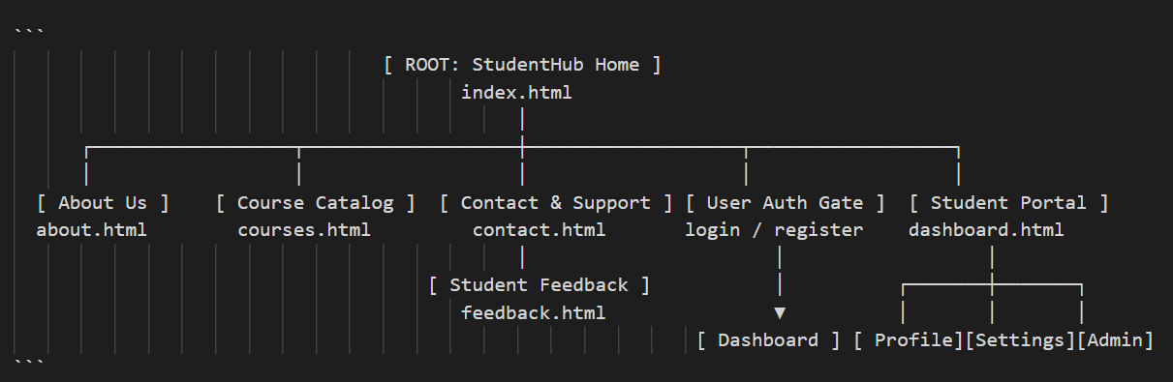

Description: wireframe image of login page

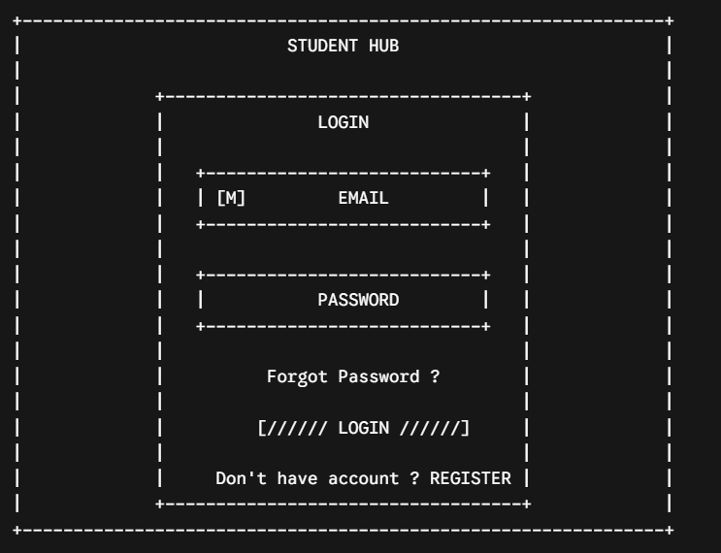

Figure 1.1

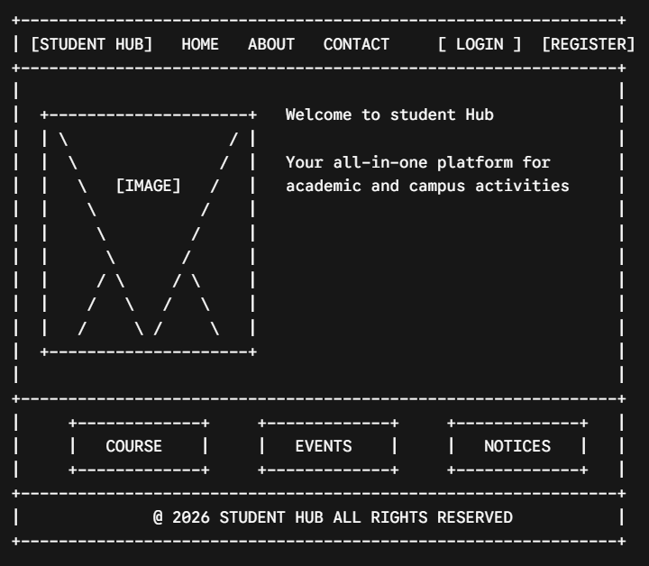

Description: wireframe image of Home page

Figure 1.2

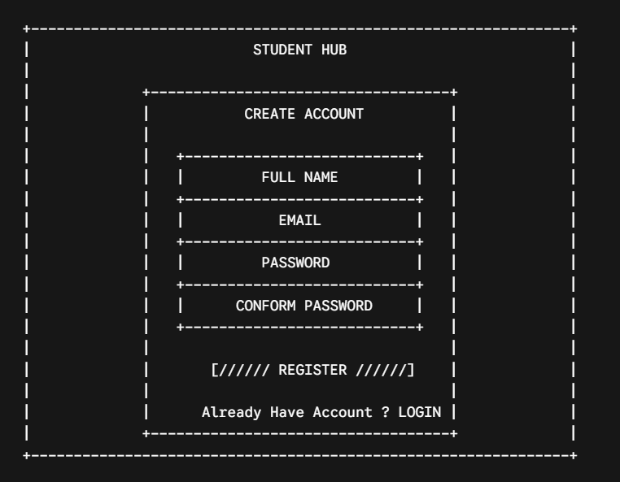

Description: wireframe image of Register page

Figure 1.3

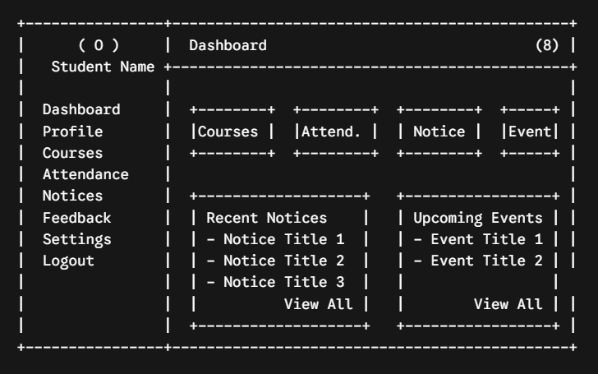

Description: wireframe image of Dashboard page

Figure 1.4

Description: wireframe image of Profie page

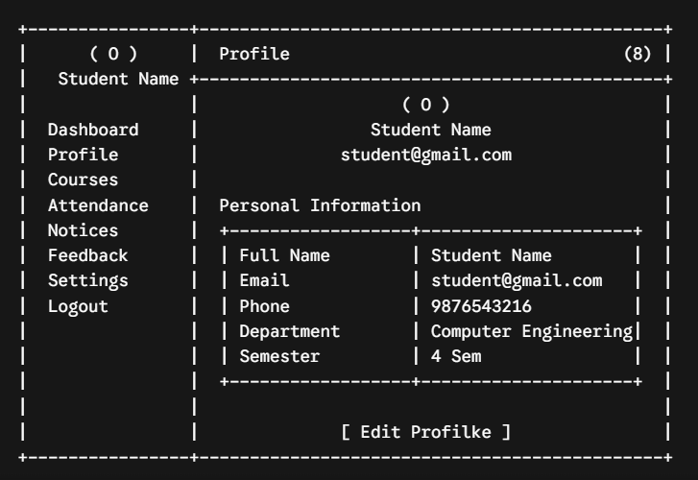
Figure 1.5

Description: wireframe image of courses page

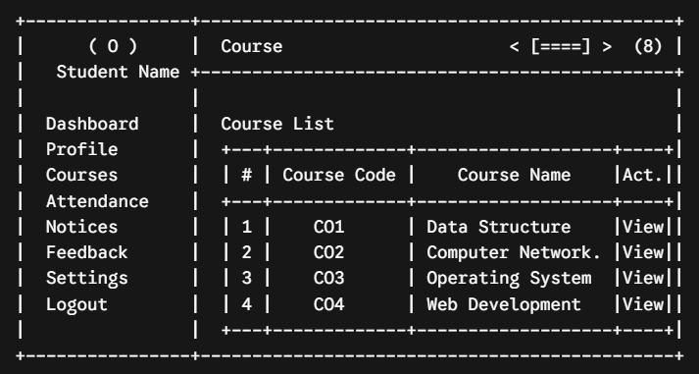
Figure 1.6

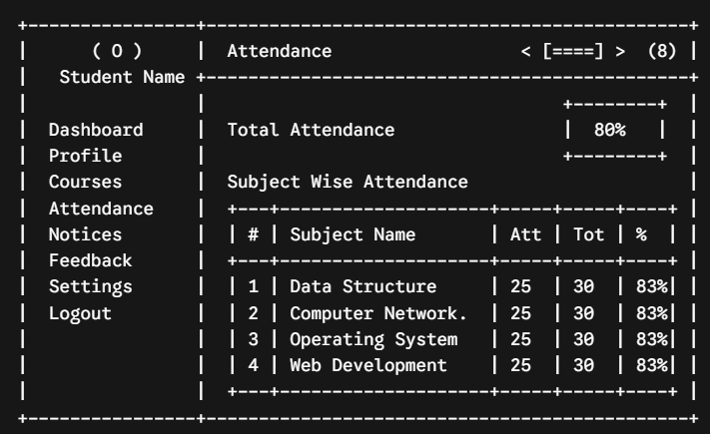
Description: wireframe image of Attendance page

Figure 1.7

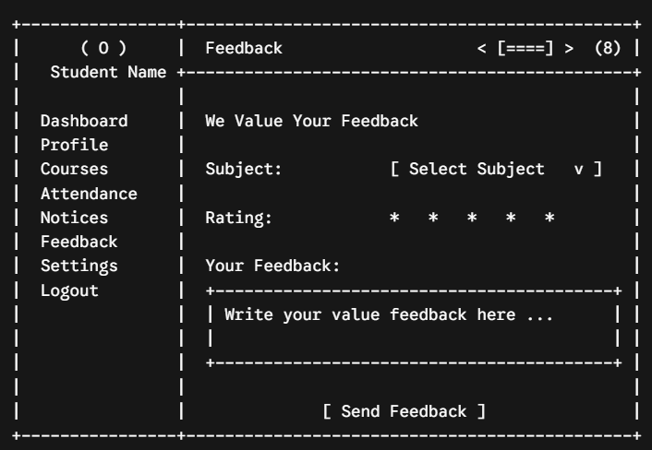
Description: wireframe image of Feedback page

Figure 1.8

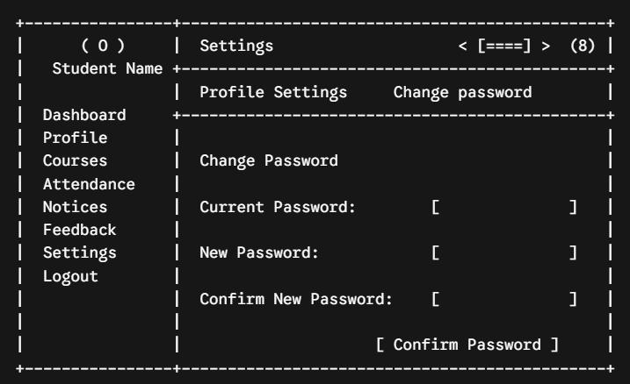
Description: wireframe image of Settings page

Figure 1.9

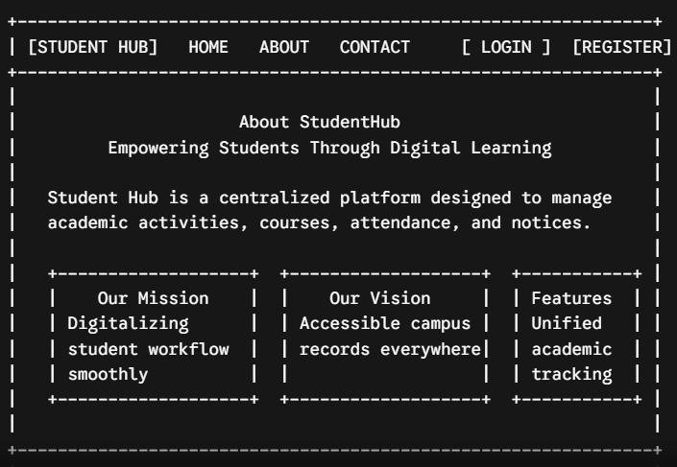
Description: wireframe image of About page

Figure 1.10

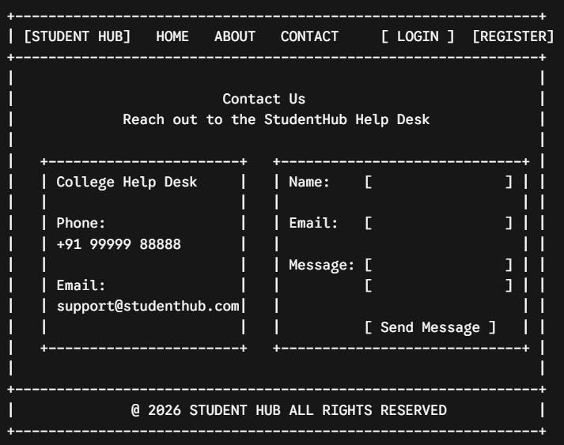

Description: wireframe image of Contact page

Figure 1.11

Practical - 2

Practical Title: Semantic HTML5 Pages with Accessibility-Ready Structure

Problem Definition: Develop static HTML5 skeletons for at least 10 StudentHub pages such as
Home, About, Register, Login, Dashboard, Events, Profile, Contact,
Admin, FAQ, and Feedback. Use semantic tags and accessibility-friendly structure.

Theory
  - Are semantic tags such as header, nav, main, section, article, aside, and footer used properly?
Answer:
No, they are only partially used.

Used correctly :- <nav>, <main>, and <section> are used properly across the pages.

Not used at all :- <header>, <footer>, <article>, and <aside> are missing from the entire folder. (e.g., The <nav> is not wrapped in a <header>, and there are no <footer> tags at the bottom of any page).

  - Are form labels, headings, image alt text, and navigation links accessible ? Answer :

Yes. Form labels are correctly bound to inputs using for and id attributes (e.g., <label for="enrolment">). Headings (<h1>, <h2>) and navigation links (<a>) are used semantically.

  - Is the page structure consistent across all pages? Answer :

Yes. The page structure is perfectly consistent.

Every page utilizes the exact same <nav class="navbar"> block at the top, followed by a <main> container for the core content.

Implementation
In this practical, the foundational structure of the StudentHub portal was developed.

Ten separate HTML pages (such as dashboard, courses, login, and result) were coded using core HTML5 elements.

Semantic tags, complex <table> structures for data presentation, and <form> elements for user input were implemented to build the raw, unstyled framework of the application.

Evidence of Work (Screenshots)
Description: home page of Student Hub
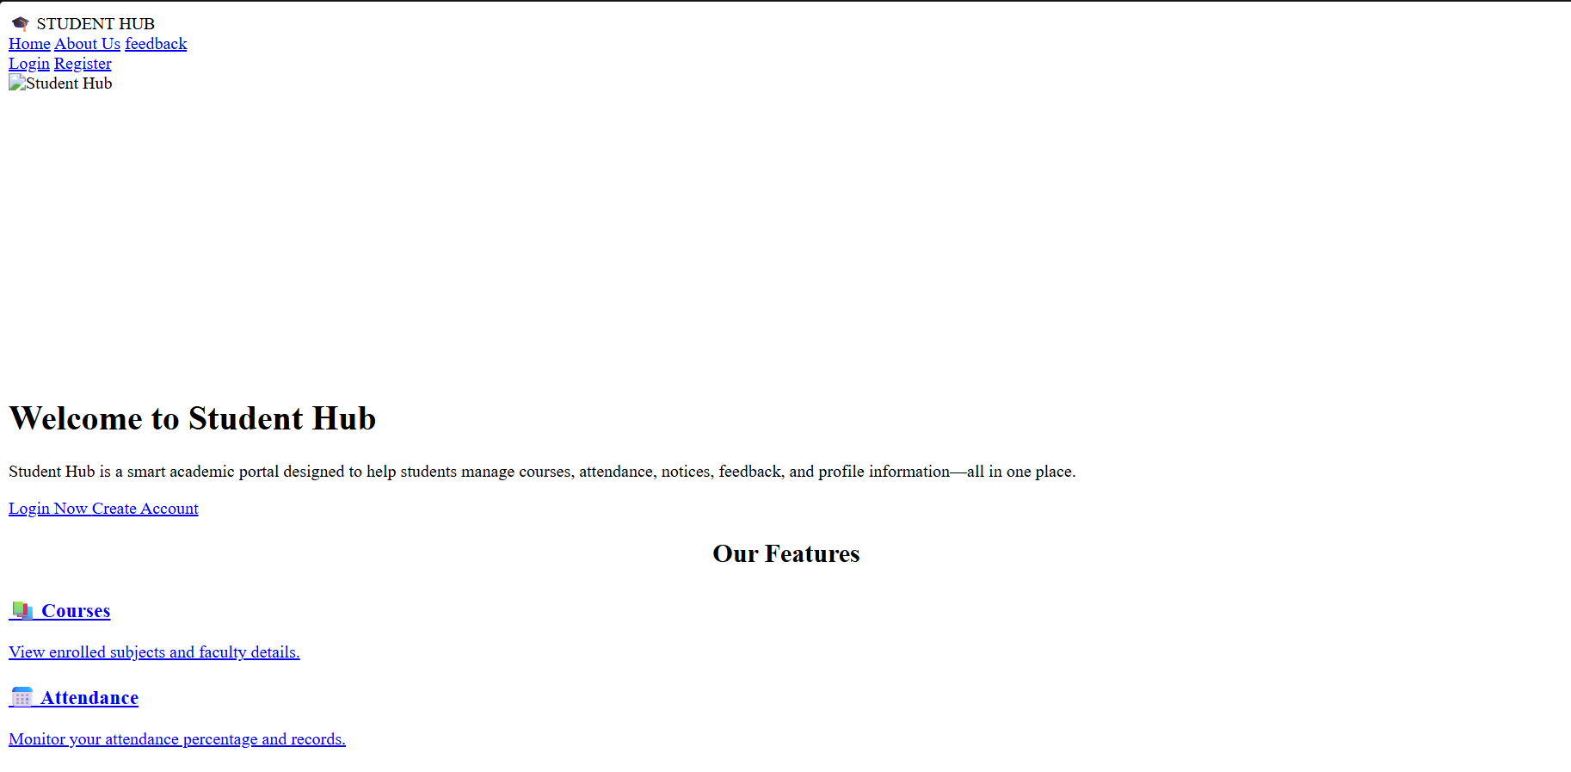

Figure 2.1

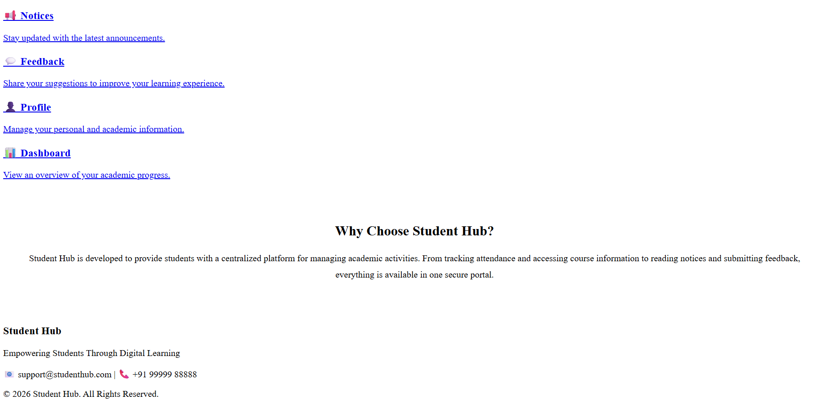
Description: dashboard page of Student Hub
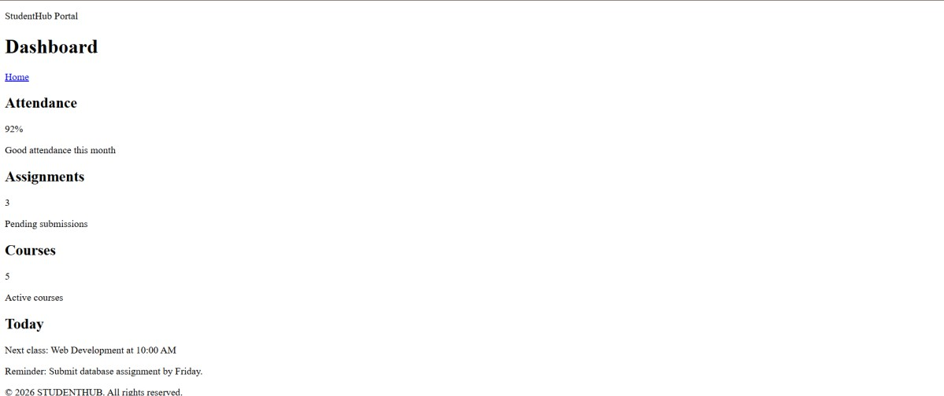
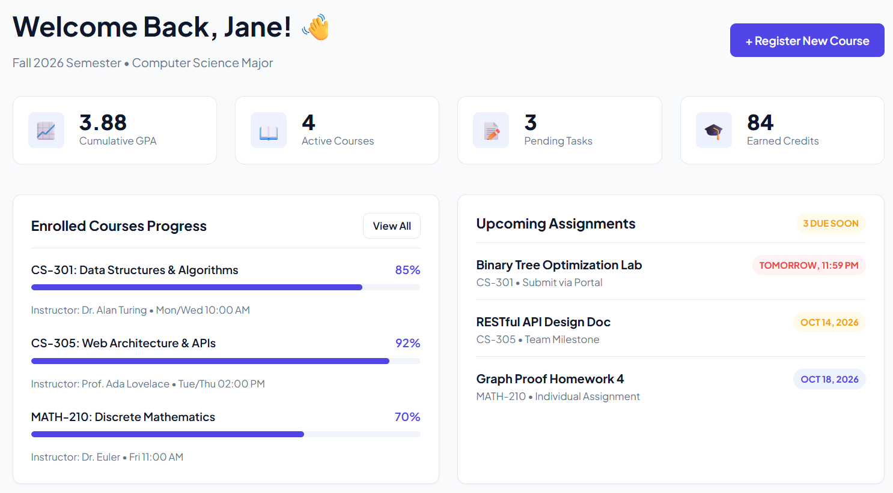 Figure 2.2

Description: Login page of Student Hub

Figure 2.3

Description: Register page of Student Hub
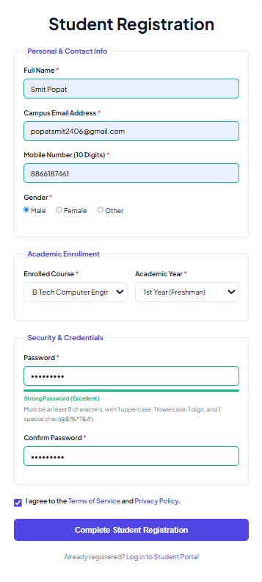
Figure 2.4

Description : Courses page of Student Hub

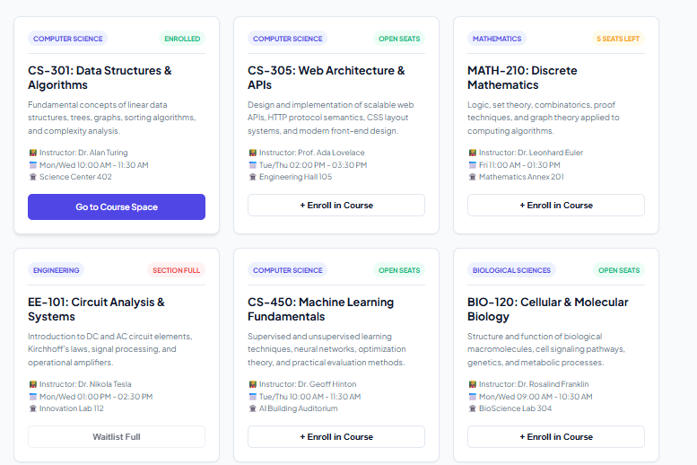

Figure 2.5
Description: Mr profile page of Student Hub
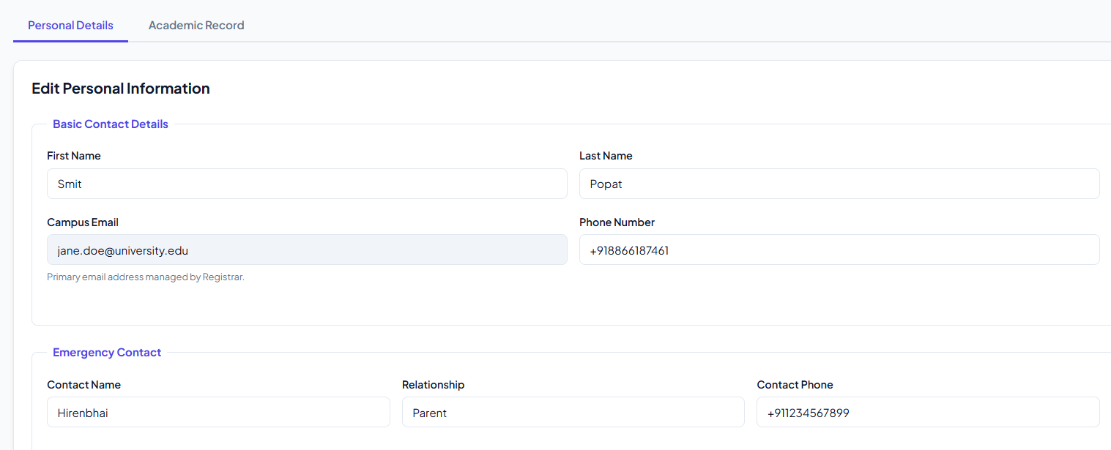

Description: Feedback page of Student Hub
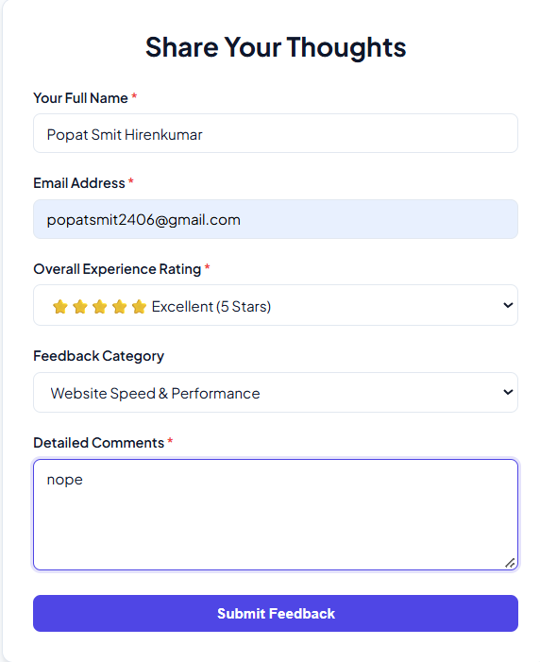

GitHub Repository Link : https://github.com/smit-2406/WDF-PRACTICAL

